ReCoverCA Homebuyer Assistance Program
Homebuyer Event – Social Media Post (template language)
Feb 25 – Event in Santa Rosa (Sonoma County)

(Graphic)
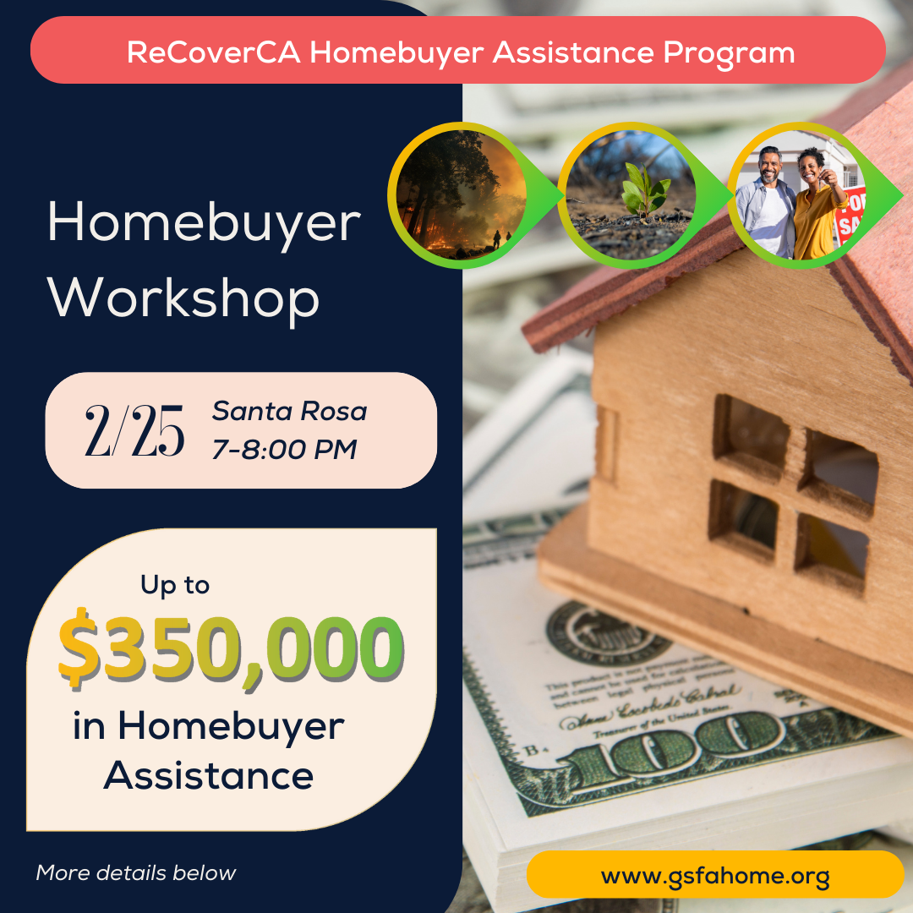

(Post body)
🏠 Sonoma County Residents -- If you were living in Sonoma County in 2017, within a High or Very High Fire Severity Zone, you could receive up to $350,000 to help you buy a home in California outside these high-risk areas.
Join us on February 25, 2025 for a FREE workshop for the ReCoverCA Homebuyer Assistance Program.
Event Details: 🗓 Date: February 25, 2025
🕖 Time: 7:00-8:00 PM
📍 Location: Finley Community Center: Santa Rosa Recreation & Parks, 2060 W College Ave., Santa Rosa, CA 95401
This workshop is open to households impacted by the 2017 wildfires in Sonoma County, as well as professionals supporting recovery efforts or providing community outreach.
🔑 What you’ll learn:
- How to apply for homebuyer assistance up to $350,000.
- Eligibility requirements, income limits, and the application process.
- Step-by-step guidance from experts in the field.
Space is limited – RSVP today!
https://qrco.de/bfg3J4
#ReCoverCA #SonomaCounty #SonomaStrong #tubbsfire #HomebuyerAssistance #DownPaymentAssistance #WildfireRecovery #CommunityRecovery #gsfa

